To create a controller we can use this command **php artisan make:controller ControllerName**

* To create a controller we can use this command **php artisan make:controller ControllerName**
* Below are 2 syntax formats for controller. First one is Laravel 7 and below, next one is Laravel 8.

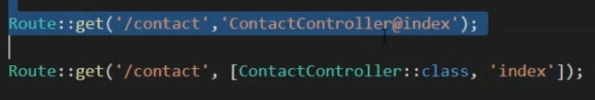

* Now we can define the index method in the controller for our business logic

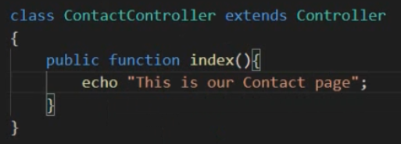

* in case we want to return a view in the controller method, we use **return view(‘view_name’);**